Test Case: tc002_SPX_Dev5_Crear_Requisicion_Spot_Tipo_Cobro_Project
Step 1 - Enter username and password and click to button Enter: Credentials Entered
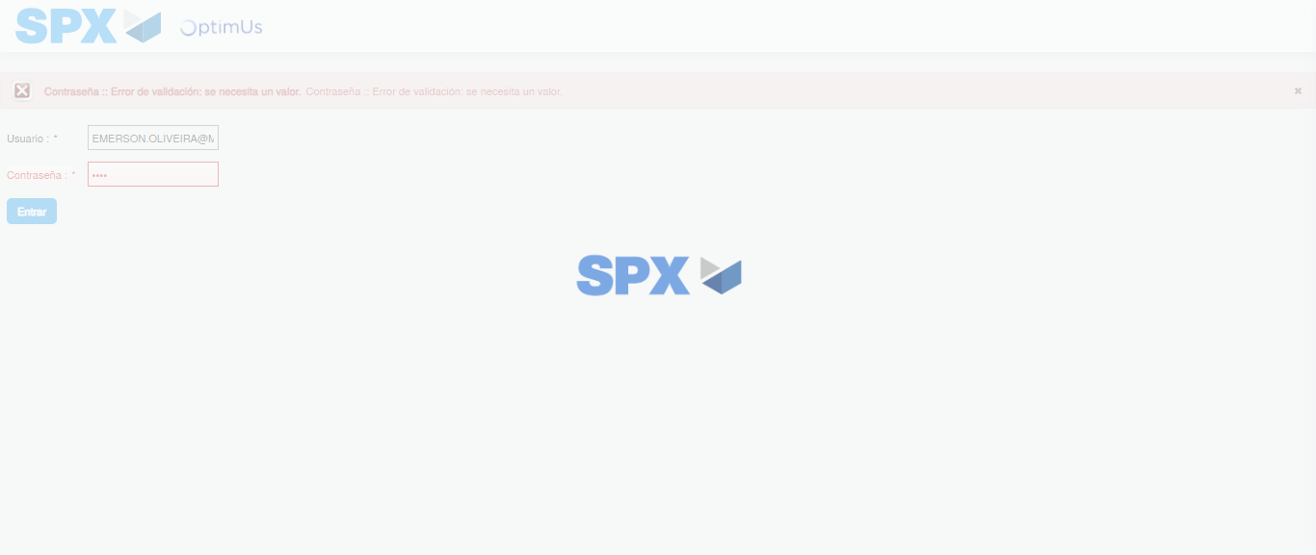Image file-name: QC_Testing-tc002_SPX_Dev5_Crear_Requisicion_Spot_Tipo_Cobro_Project-1785974216407

Step 2 - Select to UEN and Access to Spot Buy Requisitions : UEN Correctly selected and Correct access
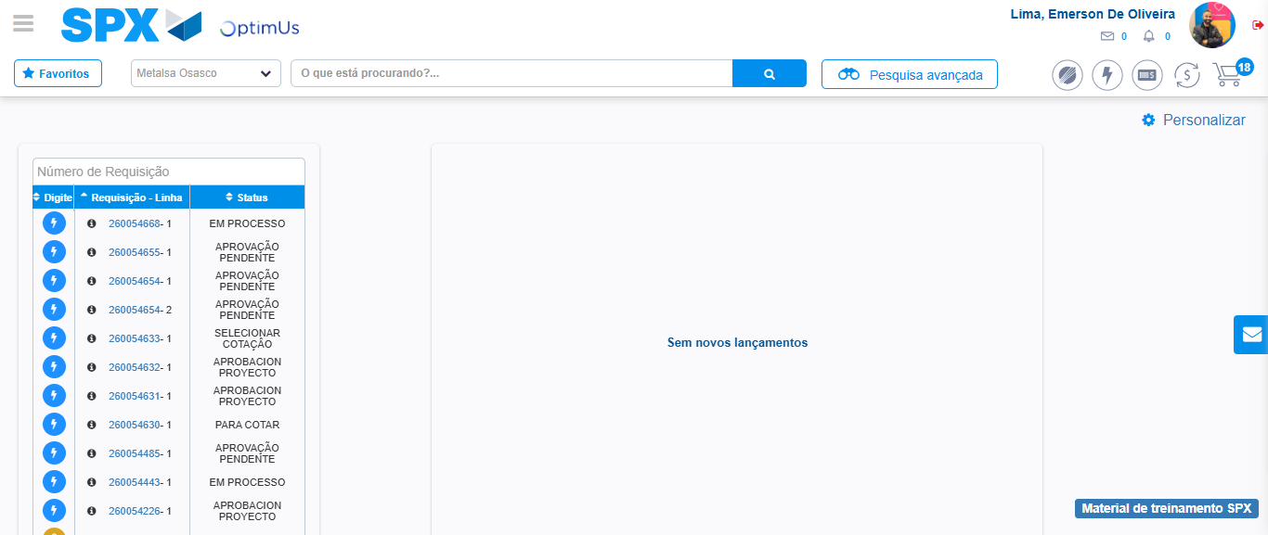Image file-name: QC_Testing-tc002_SPX_Dev5_Crear_Requisicion_Spot_Tipo_Cobro_Project-1785974241248

Image file-name: QC_Testing-tc002_SPX_Dev5_Crear_Requisicion_Spot_Tipo_Cobro_Project-1785974243717

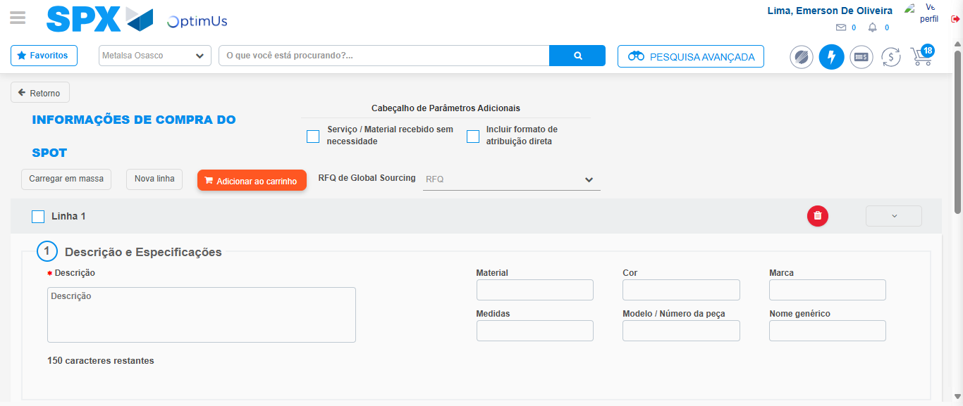Image file-name: QC_Testing-tc002_SPX_Dev5_Crear_Requisicion_Spot_Tipo_Cobro_Project-1785974252841

Step 3 - Data Capture Spot Buy Requisition: Data captured correctly
Image file-name: QC_Testing-tc002_SPX_Dev5_Crear_Requisicion_Spot_Tipo_Cobro_Project-1785974253098

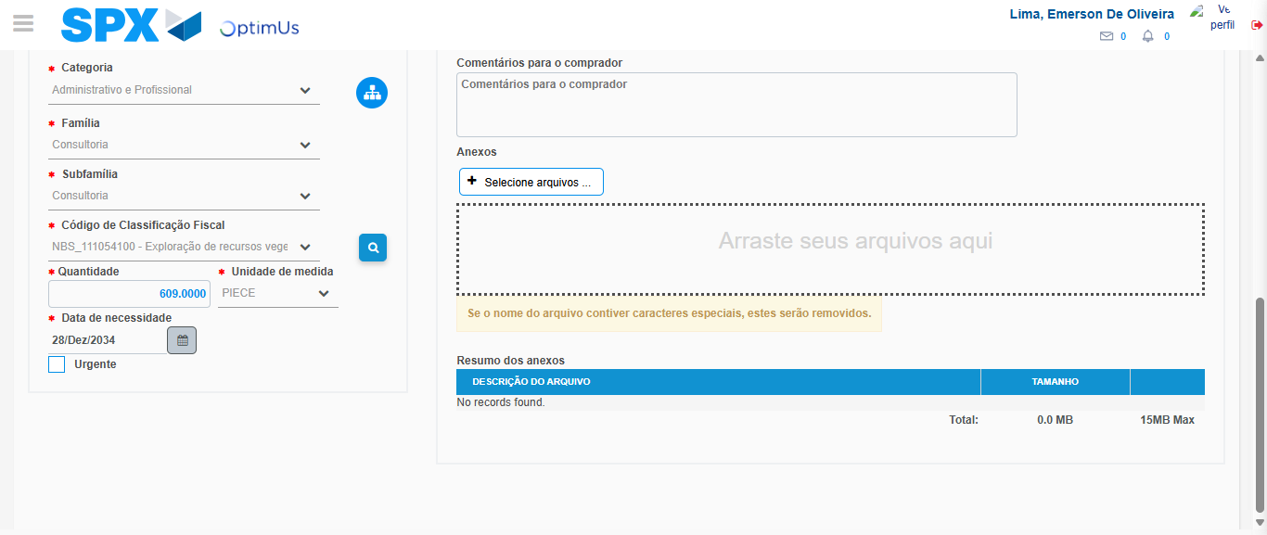Image file-name: QC_Testing-tc002_SPX_Dev5_Crear_Requisicion_Spot_Tipo_Cobro_Project-1785974269784

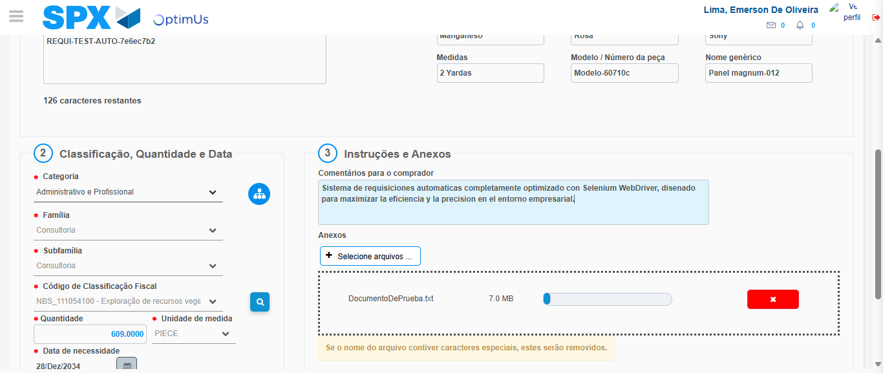Image file-name: QC_Testing-tc002_SPX_Dev5_Crear_Requisicion_Spot_Tipo_Cobro_Project-1785974270548

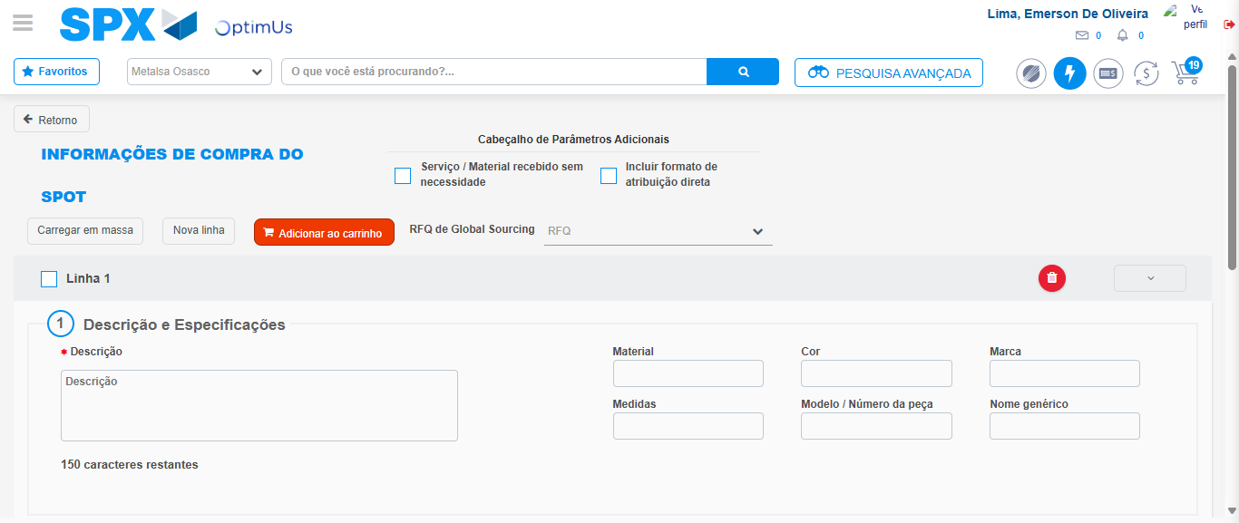Image file-name: QC_Testing-tc002_SPX_Dev5_Crear_Requisicion_Spot_Tipo_Cobro_Project-1785974275936

Step 7 - Return to Main Page SPX : Return to Main Page SPX
Image file-name: QC_Testing-tc002_SPX_Dev5_Crear_Requisicion_Spot_Tipo_Cobro_Project-1785974241248

Image file-name: QC_Testing-tc002_SPX_Dev5_Crear_Requisicion_Spot_Tipo_Cobro_Project-1785974243717

Image file-name: QC_Testing-tc002_SPX_Dev5_Crear_Requisicion_Spot_Tipo_Cobro_Project-1785974252841

Image file-name: QC_Testing-tc002_SPX_Dev5_Crear_Requisicion_Spot_Tipo_Cobro_Project-1785974278181

Image file-name: QC_Testing-tc002_SPX_Dev5_Crear_Requisicion_Spot_Tipo_Cobro_Project-1785974278359

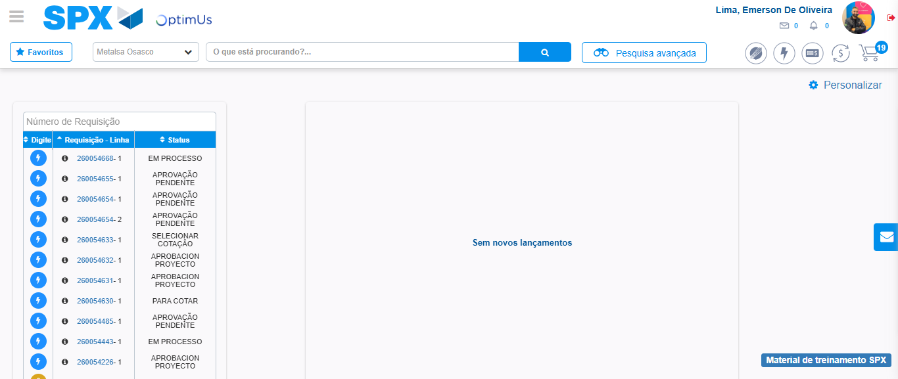Image file-name: QC_Testing-tc002_SPX_Dev5_Crear_Requisicion_Spot_Tipo_Cobro_Project-1785974299463

Step 8 - Log Out : Log Out SPX
Image file-name: QC_Testing-tc002_SPX_Dev5_Crear_Requisicion_Spot_Tipo_Cobro_Project-1785974299761

